 | Nancy Willis, Certified Pedorthist  Mobile Service: Kingston, ON  613.545.2367 or 866.683.8260  www.ceonancy.ca  ceo.nancy.willis@gmail.com

PSEUDO DOUBLE BOW…

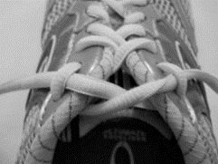 | - Lace configuration for tightening to keep heel in place.  4 | 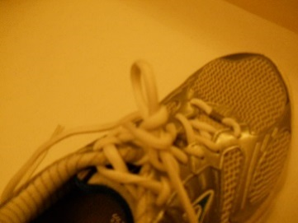 | 4. Make the first loop and wrap the other lace around it 2x.
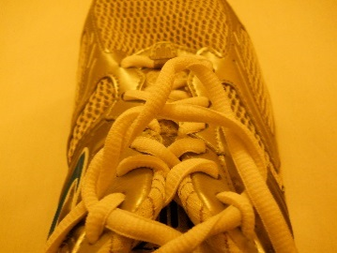 | - Wrap one lace around the other 2x (twice). | 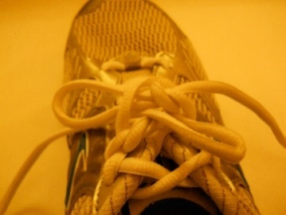 | 5. Make the second loop and push through opening.
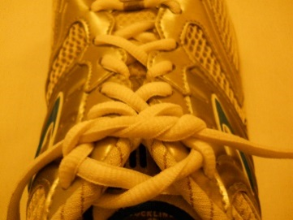 | - The laces will look like this. | 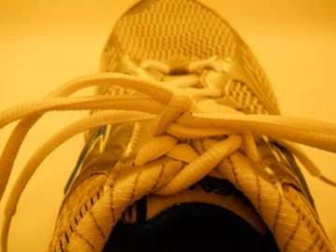 | 6. Tighten the knot by pulling the loops. Undo by pulling one end.

